PERSONAL INFORMATION | Thushar Tom
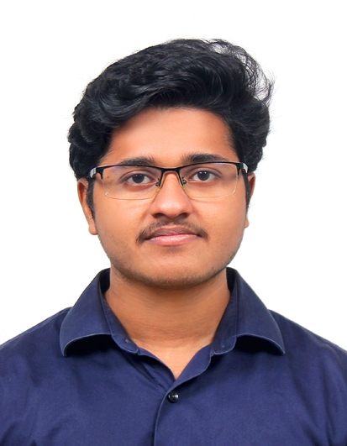 |   Kottayam, Kerala, India
 |  +91 8547934944

thushartom@gmail.com
 | Sex Male | Date of birth 21/03/1998 | Nationality Indian

WORK EXPERIENCE

1 August 2020 – Present | Software Engineer
1 August 2020 – Present | Founding Minds Software, Infopark, Kochi, Kerala, India  Python developer in the R&D wing working with vision-based hardware and software.
1 August 2020 – Present | - Integrated deep learning models into vision-based software products  - Built automated pipelines for computer vision applications  - Developed software using various technologies like Flutter, PyQt5, Flask, Django, AWS cloud, Tkinter, ……  - Implemented hardware solutions on developer boards such as Jetson nano  - US Patent
1 August 2020 – Present | Business or sector Software Company
March 2020 – July 2020 | Hardware Engineering Intern
Projects implemented -----------
- Experienced in _protocols _harware tools
- Hands-on experience with electronics hardware projects on ESP32, Raspberry Pi, Arduino, etc and worked with protocols such as UART, SPI, I2C etc
- 3D printed and modeling casing to develop finished products
- Worked with various sensors and actuators (list)

 | Business or sector Start-up

EDUCATION AND TRAINING

March 2016- December 2020 | B. Tech. in Electronics and Communication Engineering GPA - 7.44 | 2.3 German marking
March 2016- December 2020 | University - College of Engineering Chengannur,
March 2016- December 2020 | - Technical Coordinator (2019-2020)  - IEEE Robotics and Automation Society (RAS) Secretary (2019-2020)  - Special Interest Group for Humanitarian Technologies (SIGHT) Coordinator (2018-2019)  - Fabrication lab Coordinator (2017-2020)  - Student representative of the batch (2019-2020)  - Major project – Developed ML model using Keras for

PERSONAL SKILLS

Mother tongue(s) | Malayalam
Other languages | UNDERSTANDING |  | SPEAKING |  | WRITING
Other languages | Listening | Reading | Spoken interaction | Spoken production
Replace with language | A1 | A1 | A1 | A1 | A1
 | Goethe A1 Certificate
Replace with language | C2 | B2 | C2 | C2 | B1
 | IELTS band 7
Levels: A1/2: Basic user - B1/2: Independent user - C1/2 Proficient user
Common European Framework of Reference for Languages

Communication skills | Replace with your communication skills. Specify in what context they were acquired. Example:  - good communication skills gained through my experience as sales manager

Organisational / managerial skills | Replace with your organisational / managerial skills. Specify in what context they were acquired. Example:  - leadership (currently responsible for a team of 10 people)
Job-related skills | Replace with any job-related skills not listed elsewhere. Specify in what context they were acquired. Example:  - good command of quality control processes (currently responsible for quality audit)

Computer skills | Replace with your computer skills. Specify in what context they were acquired. Example:  - good command of Microsoft Office™ tools

Other skills | Replace with other relevant skills not already mentioned. Specify in what context they were acquired. Example:  - carpentry

Driving licence | Replace with driving licence category/-ies. Example:  - B

ADDITIONAL INFORMATION

Publications  Presentations  Projects  Conferences  Seminars  Honours and awards  Memberships  References | Replace with relevant publications, presentations, projects, conferences, seminars, honours and awards, memberships, references. Remove headings not relevant in the left column.  Example of publication:  - How to write a successful CV, New Associated Publishers, London, 2002.  Example of project:  - Devon new public library. Principal architect in charge of design, production, bidding and construction supervision (2008-2012).

